LAB 6

1.

Top of Form

public class StringConstructorExample {  
    public static void main(String[] args) {  
  
        String str1 = "Hello, World!";  
  
        char[] charArray = {'H', 'e', 'l', 'l', 'o'};  
        String str2 = new String(charArray);  
  
        String original = "Java Programming";  
        String str3 = new String(original);  
  
  
        StringBuilder stringBuilder = new StringBuilder("Java");  
        String str4 = new String(stringBuilder);        byte[] byteArray = {65, 66, 67, 68, 69}; // ASCII values for A, B, C, D, E  
        String str5 = new String(byteArray);  
  
         
        char[] charArray2 = {'J', 'a', 'v', 'a', ' ', 'P', 'r', 'o', 'g', 'r', 'a', 'm', 'm', 'i', 'n', 'g'};  
        String str6 = new String(charArray2, 0, 4); // "Java"  
  
        byte[] byteArray2 = {65, 66, 67, 68, 69}; // ASCII values for A, B, C, D, E  
        String str7 = new String(byteArray2, 1, 3); // "BCD"  
  
        System.out.println(str1);  
        System.out.println(str2);  
        System.out.println(str3);  
        System.out.println(str4);  
        System.out.println(str5);  
        System.out.println(str6);  
        System.out.println(str7);  
    }  
}

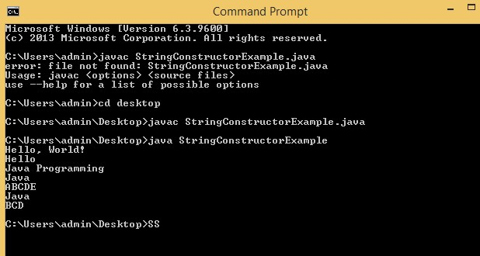

|  |
| --- |
|  |
|  |
|  |

|  |
| --- |
|  |
|  |
|  |

2. public class StringOperationsDemo {  
    public static void main(String[] args) {  
  
        String str1 = "Hello, ";  
        String str2 = "Java!";  
         
  
        String result = str1 + str2;  
  
  
        int length = result.length();  
  
  
        System.out.println("String 1: " + str1);  
        System.out.println("String 2: " + str2);  
        System.out.println("Concatenated String: " + result);  
        System.out.println("Length of Concatenated String: " + length);  
    }  
}

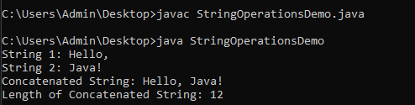

3.4) public class College {  
    private String name;  
  
     
    public College(String name) {  
        [this.name](http://this.name/) = name;  
    }  
  
     
  
    public String toString() {  
        return "College{name='" + name + "'}";  
    }  
  
     
    public void extractSubstring() {  
        char[] targetArray = new char[5];    
         
        name.getChars(11, 16, targetArray, 0);  
  
  
        System.out.println("Extracted Substring: " + new String(targetArray));  
    }  
  
    public static void main(String[] args) {  
         
        College myCollege = new College("Welcome to Bmsce college");  
  
         
        System.out.println(myCollege);  
  
         
        myCollege.extractSubstring();  
    }  
}

. 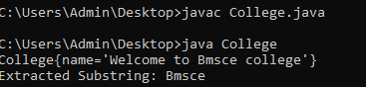

5. public class GetBytesDemo {  
    public static void main(String[] args) {  
        String myString = "Hello, World!";  
  
  
        byte[] byteArray = myString.getBytes();  
  
               System.out.println("Bytes representation:");  
        for (byte b : byteArray) {  
            System.out.print(b + " ");  
        }  
  
               System.out.println("\nOriginal String: " + myString);  
    }  
}

public class ToCharArrayDemo {  
    public static void main(String[] args) {  
        String myString = "Java Programming";  
  
        char[] charArray = myString.toCharArray();  
  
  
        System.out.println("Char array representation:");  
        for (char c : charArray) {  
            System.out.print(c + " ");  
        }  
  
      // Display the original string  
        System.out.println("\nOriginal String: " + myString);  
    }

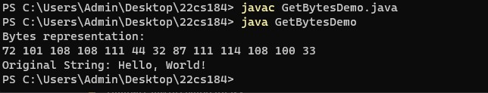

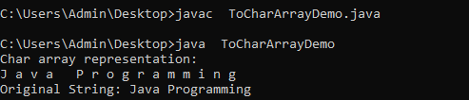

PROGRAM-6

SOURCE CODE:

public class StringComparison {

public static void main(String[] args) {

String str1 = "Bmsce";

String str2 = "Bmsce";

boolean isEqual = str1.equals(str2);

System.out.println(str1 + " equals " + str2 + " -> " + isEqual);

String str3 = "Bmsce";

String str4 = "College";

isEqual = str3.equals(str4);

System.out.println(str3 + " equals " + str4 + " -> " + isEqual);

String str5 = "Bmsce";

String str6 = "BMSCE";

isEqual = str5.equals(str6);

System.out.println(str5 + " equals " + str6 + " -> " + isEqual);

String str7 = "Bmsce";

String str8 = "BMSCE";

boolean isEqualIgnoreCase = str7.equalsIgnoreCase(str8);

System.out.println(str7 + " equalsIgnoreCase " + str8 + " -> " + isEqualIgnoreCase);

}

}

OUTPUT:

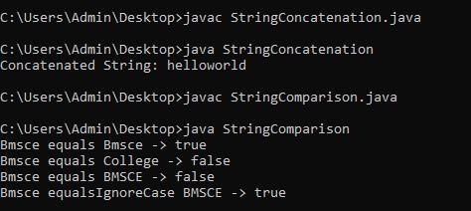

PROGRAM-7

SOURCE CODE:

public class Find{

public static void main(String args[]){

String str1="Welcome to BMSCE College of Engineering";

String otherstr="BMSCE College";

Boolean ismatch=str1.regionMatches(true, 11,otherstr,0,otherstr.length());

if(ismatch)

System.out.println("substring is matched");

else

System.out.println("substring is not matched");

}

}

OUTPUT:

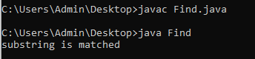

PROGRAM-8 and 9

SOURCE CODE:

public class StartEndDemo {  
    public static void main(String[] args) {  
        String mainString1 = "Hello, World!";  
        String pre1 = "Hello";  
        boolean startsWith1 = mainString1.startsWith(pre1);  
        System.out.println( mainString1 +"starts with"+ pre1 + " -> " + startsWith1);  
  
        String mainString2 = "Java Programming";  
        String prefix2 = "Python";  
        boolean startsWith2 = mainString2.startsWith(prefix2);  
        System.out.println( mainString2 + " starts with " + prefix2 + " -> " + startsWith2);  
  
        String mainString3 = "Hello, World!";  
        String suffix1 = "World!";  
        boolean endsWith1 = mainString3.endsWith(suffix1);  
        System.out.println( mainString3 + "ends with " + suffix1 + " -> " + endsWith1);  
  
        String mainString4 = "Java Programming";  
        String suffix2 = "C++";  
        boolean endsWith2 = mainString4.endsWith(suffix2);  
        System.out.println(mainString4 + " ends with " + suffix2 + " -> " + endsWith2);  
    }  
}

OUTPUT:

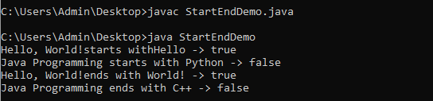

PROGRAM-10

SOURCE CODE:

class EqualsNotEqualTo{  
public static void main(String args[]){  
String s1="Hello!";  
String s2= new String(s1);  
System.out.println(s1 + " equals " + s2 + " -> " + s1.equals(s2));  
System.out.println(s1 + " == " + s2 + " -> " + (s1 == s2));  
  }  
}

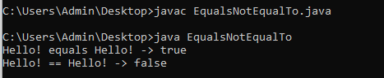

PROGRAM-11

SOURCE CODE:

import java.util.Arrays;

public class AlphabetSorting {

public static void main(String[] args) {

String[] words = {"van", "watch", "ball", "cat", "xmas", "yatch", "zee", "apple", "ice", "jug", "kite", "lift", "man", "net", "orange", "dog", "ent", "free", "gun", "hen", "parrot", "queen", "ring", "star", "tree", "umbrella"};

Arrays.sort(words);

System.out.println("Sorted Words:");

for (String word : words) {

System.out.println(word);

}

}

}

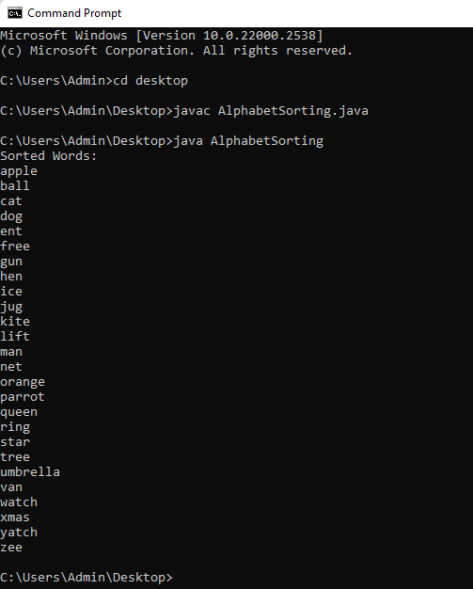OUTPUT:

PROGRAM-12

SOURCE CODE:

import java.util.Arrays;

public class NumberSorting {

public static void main(String[] args) {

Integer[] numbers = {10, 9, 8, 7, 6, 5, 4, 3, 2, 1};

Arrays.sort(numbers, (num1, num2) -> num2.compareTo(num1));

System.out.println("Sorted Numbers (Descending Order):");

for (Integer number : numbers) {

System.out.println(number);

}

}

}

OUTPUT:

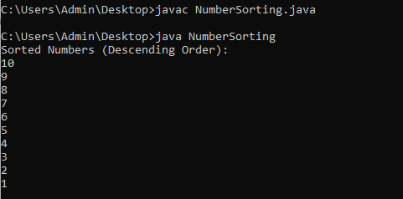

PROGRAM-13

SOURCE CODE:

public class StringReplacement {

public static void main(String[] args) {

String originalString = "Thwas was a test. Thwas was, too.";

int indexOfWas = originalString.indexOf("was");

while (indexOfWas != -1) {

String updatedString = originalString.substring(0, indexOfWas) + "is" + originalString.substring(indexOfWas + "was".length());

originalString = updatedString;

indexOfWas = originalString.indexOf("was");

}

System.out.println("Modified String: " + originalString);

}

}

OUTPUT:

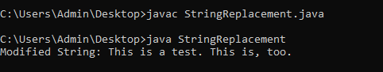

PROGRAM-14

SOURCE CODE:

public class StringConcatenation {

public static void main(String[] args) {

String s1 = "hello";

String s2 = "world";

String result = s1.concat(s2);

System.out.println("Concatenated String: " + result);

}

}

OUTPUT:

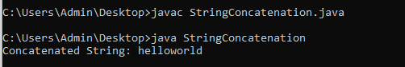

PROGRAM-15

SOURCE CODE:

public class StringReplaceDemo {

public static void main(String[] args) {

String originalString = &quot;This is my College.&quot;;

String modifiedString = originalString.replace(&quot;College&quot;, &quot;Commege&quot;);

System.out.println(&quot;Original String: &quot; + originalString);

System.out.println(&quot;Modified String: &quot; + modifiedString);

}

}

OUTPUT:

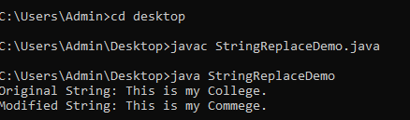

PROGRAM-16

SOURCE CODE:

public class StringTrimDemo {

public static void main(String[] args) {

String originalString = &quot; Hello Friends &quot;;

String trimmedString = originalString.trim();

System.out.println(&quot;Original String: &#39;&quot; + originalString + &quot;&#39;&quot;);

System.out.println(&quot;Trimmed String: &#39;&quot; + trimmedString + &quot;&#39;&quot;);

}

}

OUTPUT:

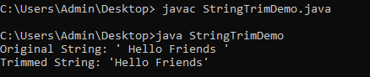

PROGRAM-17

SOURCE CODE:

import java.util.Arrays;

import java.util.Scanner;

class Student {

private int regNumber;

private String fullName;

private short semester;

private float cgpa;

public Student() {

this.regNumber = 0;

this.fullName = &quot;&quot;;

this.semester = 0;

this.cgpa = 0.0f;

}

public Student(int regNumber, String fullName, short semester, float cgpa) {

this.regNumber = regNumber;

this.fullName = fullName;

this.semester = semester;

this.cgpa = cgpa;

}

public void display() {

System.out.println(&quot;Registration Number: &quot; + regNumber);

System.out.println(&quot;Full Name: &quot; + fullName);

System.out.println(&quot;Semester: &quot; + semester);

System.out.println(&quot;CGPA: &quot; + cgpa);

System.out.println();

}

public float getCGPA() {

return cgpa;

}

public String getFullName() {

return fullName;

}

}

public class StudentRecords {

public static void main(String[] args) {

Scanner scanner = new Scanner(System.in);

Student[] students = new Student[5];

for (int i = 0; i &lt; students.length; i++) {

System.out.println(&quot;Enter details for Student &quot; + (i + 1) + &quot;:&quot;);

System.out.print(&quot;Registration Number: &quot;);

int regNumber = scanner.nextInt();

scanner.nextLine(); // Consume the newline

System.out.print(&quot;Full Name: &quot;);

String fullName = scanner.nextLine();

System.out.print(&quot;Semester: &quot;);

short semester = scanner.nextShort();

System.out.print(&quot;CGPA: &quot;);

float cgpa = scanner.nextFloat();

students[i] = new Student(regNumber, fullName, semester, cgpa);

}

System.out.println(&quot;Displaying Student Records:&quot;);

for (Student student : students) {

student.display();

}

Arrays.sort(students, (s1, s2) -&gt; Float.compare(s2.getCGPA(), s1.getCGPA()));

System.out.println(&quot;Student Records Sorted by CGPA:&quot;);

for (Student student : students) {

student.display();

}

Arrays.sort(students, (s1, s2) -&gt; s1.getFullName().compareTo(s2.getFullName()));

System.out.println(&quot;Student Records Sorted by Name:&quot;);

for (Student student : students) {

student.display();

}

}

}

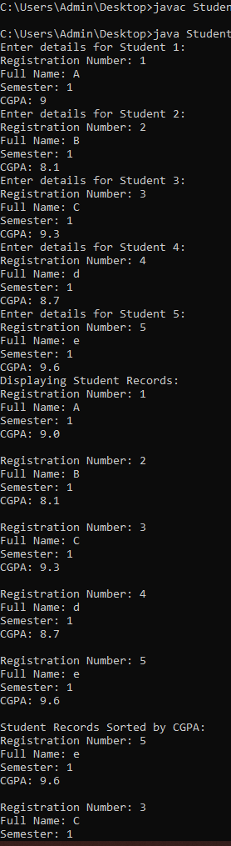OUTPUT:

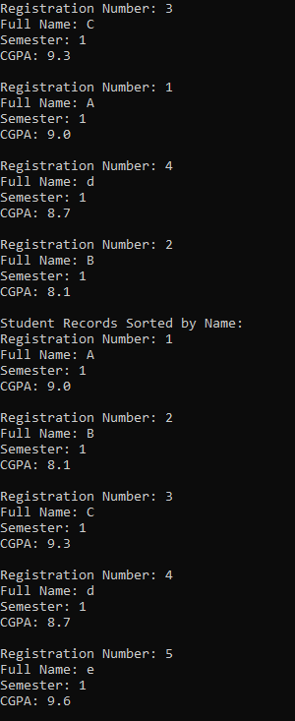

PROGRAM-18

SOURCE CODE:

public class StringBufferDemo {

public static void main(String[] args) {

StringBuffer stringBuffer = new StringBuffer(&quot;Hello, StringBuffer!&quot;);

stringBuffer.setLength(5);

System.out.println(&quot;After setLength(5): &quot; + stringBuffer);

char charAtIndex = stringBuffer.charAt(1);

System.out.println(&quot;Character at index 1: &quot; + charAtIndex);

stringBuffer.setCharAt(1, &#39;a&#39;);

System.out.println(&quot;After setCharAt(1, &#39;a&#39;): &quot; + stringBuffer);

char[] charArray = new char[5];

stringBuffer.getChars(0, 5, charArray, 0);

System.out.println(&quot;Characters from index 0 to 4: &quot; + new String(charArray));

stringBuffer.append(&quot; Appended!&quot;);

System.out.println(&quot;After append(): &quot; + stringBuffer);

stringBuffer.insert(7, &quot;Inserted &quot;);

System.out.println(&quot;After insert(7, &#39;Inserted &#39;): &quot; + stringBuffer);

stringBuffer.reverse();

System.out.println(&quot;After reverse(): &quot; + stringBuffer);

stringBuffer.delete(5, 14);

System.out.println(&quot;After delete(5, 14): &quot; + stringBuffer);

stringBuffer.deleteCharAt(0);

System.out.println(&quot;After deleteCharAt(0): &quot; + stringBuffer);

stringBuffer.replace(0, 4, &quot;Replaced&quot;);

System.out.println(&quot;After replace(0, 4, &#39;Replaced&#39;): &quot; + stringBuffer);

String substring = stringBuffer.substring(3, 8);

System.out.println(&quot;Substring from index 3 to 7: &quot; + substring);

}

}

OUTPUT:

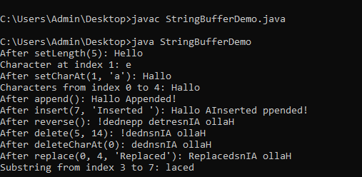

PROGRAM-19

SOURCE CODE:

Abstract class Bird

abstract class Bird {

abstract void fly();

abstract void makeSound();

}

class Eagle extends Bird {

void fly() {

System.out.println(&quot;Eagle flies high in the sky with powerful wings.&quot;);

}

void makeSound() {

System.out.println(&quot;Eagle makes a sharp and distinctive cry.&quot;);

}

}

class Hawk extends Bird {

void fly() {

System.out.println(&quot;Hawk soars through the air with agile maneuvers.&quot;);

}

void makeSound() {

System.out.println(&quot;Hawk emits a high-pitched screech while flying.&quot;);

}

}

public class BirdTest {

public static void main(String[] args) {

Eagle eagle = new Eagle();

Hawk hawk = new Hawk();

System.out.println(&quot;Details about Eagle:&quot;);

eagle.fly();

eagle.makeSound();

System.out.println(&quot;\nDetails about Hawk:&quot;);

hawk.fly();

hawk.makeSound();

}

}

OUTPUT:

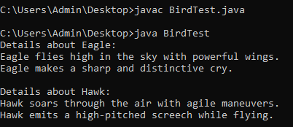

PROGRAM-20

SOURCE CODE:

abstract class Shape {

abstract double calculateArea();

abstract double calculatePerimeter();

}

class Circle extends Shape {

private double radius;

public Circle(double radius) {

this.radius = radius;

}

double calculateArea() {

return Math.PI * radius * radius;

}

double calculatePerimeter() {

return 2 * Math.PI * radius;

}

}

class Triangle extends Shape {

private double side1, side2, side3;

public Triangle(double side1, double side2, double side3) {

this.side1 = side1;

this.side2 = side2;

this.side3 = side3;

}

double calculateArea() {

double s = (side1 + side2 + side3) / 2.0;

return Math.sqrt(s * (s - side1) * (s - side2) * (s - side3));

}

double calculatePerimeter() {

return side1 + side2 + side3;

}

}

public class ShapeTest {

public static void main(String[] args) {

Circle circle = new Circle(5.0);

Triangle triangle = new Triangle(3.0, 4.0, 5.0);

System.out.println(&quot;Details about Circle:&quot;);

System.out.println(&quot;Area: &quot; + circle.calculateArea());

System.out.println(&quot;Perimeter: &quot; + circle.calculatePerimeter());

System.out.println(&quot;\nDetails about Triangle:&quot;);

System.out.println(&quot;Area: &quot; + triangle.calculateArea());

System.out.println(&quot;Perimeter: &quot; + triangle.calculatePerimeter());

}

}

OUTPUT:

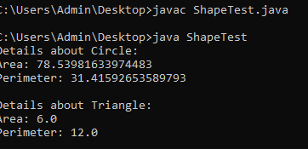

7.

8.

9.

10.

11.

12.

12.

13. class StringReplace {

public static void main(String args[]) {

String org = "Thwas was a test. Thwas was,too.";

String search = "was";

String sub = "is";

String result = "";

int i;

do {

System.out.println(org);

i = org.indexOf(search);

if(i != -1) {

result = org.substring(0, i);

result = result + sub;

result = result + org.substring(i + search.length());

org = result;

}

} while(i != -1);

}

}

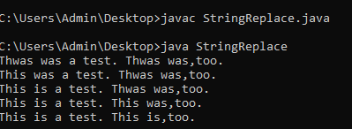

15. public class StringReplaceDemo {

public static void main(String[] args) {

String originalString = "This is my College.";

String modifiedString = originalString.replace("College", "Commege");

System.out.println("Original String: " + originalString);

System.out.println("Modified String: " + modifiedString);

}

}

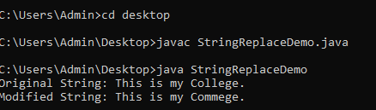

16. public class StringTrimDemo {

public static void main(String[] args) {

String originalString = " Hello Friends ";

String trimmedString = originalString.trim();

System.out.println("Original String: '" + originalString + "'");

System.out.println("Trimmed String: '" + trimmedString + "'");

}

}

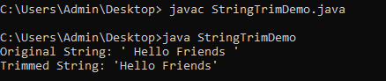

17. import java.util.Arrays;

import java.util.Scanner;

class Student {

private int regNumber;

private String fullName;

private short semester;

private float cgpa;

public Student() {

this.regNumber = 0;

this.fullName = "";

this.semester = 0;

this.cgpa = 0.0f;

}

public Student(int regNumber, String fullName, short semester, float cgpa) {

this.regNumber = regNumber;

this.fullName = fullName;

this.semester = semester;

this.cgpa = cgpa;

}

public void display() {

System.out.println("Registration Number: " + regNumber);

System.out.println("Full Name: " + fullName);

System.out.println("Semester: " + semester);

System.out.println("CGPA: " + cgpa);

System.out.println();

}

public float getCGPA() {

return cgpa;

}

public String getFullName() {

return fullName;

}

}

public class StudentRecords {

public static void main(String[] args) {

Scanner scanner = new Scanner(System.in);

Student[] students = new Student[5];

for (int i = 0; i < students.length; i++) {

System.out.println("Enter details for Student " + (i + 1) + ":");

System.out.print("Registration Number: ");

int regNumber = scanner.nextInt();

scanner.nextLine(); // Consume the newline

System.out.print("Full Name: ");

String fullName = scanner.nextLine();

System.out.print("Semester: ");

short semester = scanner.nextShort();

System.out.print("CGPA: ");

float cgpa = scanner.nextFloat();

students[i] = new Student(regNumber, fullName, semester, cgpa);

}

System.out.println("Displaying Student Records:");

for (Student student : students) {

student.display();

}

Arrays.sort(students, (s1, s2) -> Float.compare(s2.getCGPA(), s1.getCGPA()));

System.out.println("Student Records Sorted by CGPA:");

for (Student student : students) {

student.display();

}

Arrays.sort(students, (s1, s2) -> s1.getFullName().compareTo(s2.getFullName()));

System.out.println("Student Records Sorted by Name:");

for (Student student : students) {

student.display();

}

}

}

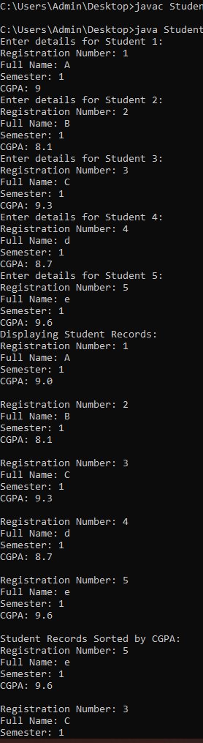

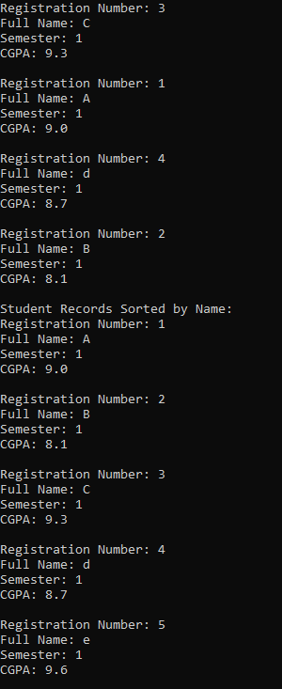

18. public class StringBufferDemo {

public static void main(String[] args) {

StringBuffer stringBuffer = new StringBuffer("Hello, StringBuffer!");

stringBuffer.setLength(5);

System.out.println("After setLength(5): " + stringBuffer);

char charAtIndex = stringBuffer.charAt(1);

System.out.println("Character at index 1: " + charAtIndex);

stringBuffer.setCharAt(1, 'a');

System.out.println("After setCharAt(1, 'a'): " + stringBuffer);

char[] charArray = new char[5];

stringBuffer.getChars(0, 5, charArray, 0);

System.out.println("Characters from index 0 to 4: " + new String(charArray));

stringBuffer.append(" Appended!");

System.out.println("After append(): " + stringBuffer);

stringBuffer.insert(7, "Inserted ");

System.out.println("After insert(7, 'Inserted '): " + stringBuffer);

stringBuffer.reverse();

System.out.println("After reverse(): " + stringBuffer);

stringBuffer.delete(5, 14);

System.out.println("After delete(5, 14): " + stringBuffer);

stringBuffer.deleteCharAt(0);

System.out.println("After deleteCharAt(0): " + stringBuffer);

stringBuffer.replace(0, 4, "Replaced");

System.out.println("After replace(0, 4, 'Replaced'): " + stringBuffer);

String substring = stringBuffer.substring(3, 8);

System.out.println("Substring from index 3 to 7: " + substring);

}

}

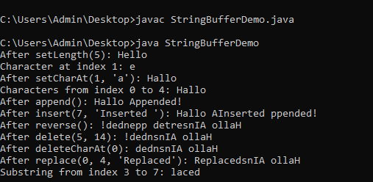

19.

abstract class Bird {

abstract void fly();

abstract void makeSound();

}

class Eagle extends Bird {

void fly() {

System.out.println("Eagle flies high in the sky with powerful wings.");

}

void makeSound() {

System.out.println("Eagle makes a sharp and distinctive cry.");

}

}

class Hawk extends Bird {

void fly() {

System.out.println("Hawk soars through the air with agile maneuvers.");

}

void makeSound() {

System.out.println("Hawk emits a high-pitched screech while flying.");

}

}

public class BirdTest {

public static void main(String[] args) {

Eagle eagle = new Eagle();

Hawk hawk = new Hawk();

System.out.println("Details about Eagle:");

eagle.fly();

eagle.makeSound();

System.out.println("\nDetails about Hawk:");

hawk.fly();

hawk.makeSound();

}

}

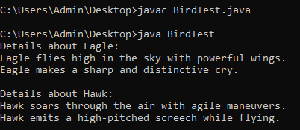

20.

abstract class Shape {

abstract double calculateArea();

abstract double calculatePerimeter();

}

class Circle extends Shape {

private double radius;

public Circle(double radius) {

this.radius = radius;

}

double calculateArea() {

return Math.PI * radius * radius;

}

double calculatePerimeter() {

return 2 * Math.PI * radius;

}

}

class Triangle extends Shape {

private double side1, side2, side3;

public Triangle(double side1, double side2, double side3) {

this.side1 = side1;

this.side2 = side2;

this.side3 = side3;

}

double calculateArea() {

double s = (side1 + side2 + side3) / 2.0;

return Math.sqrt(s * (s - side1) * (s - side2) * (s - side3));

}

double calculatePerimeter() {

return side1 + side2 + side3;

}

}

public class ShapeTest {

public static void main(String[] args) {

Circle circle = new Circle(5.0);

Triangle triangle = new Triangle(3.0, 4.0, 5.0);

System.out.println("Details about Circle:");

System.out.println("Area: " + circle.calculateArea());

System.out.println("Perimeter: " + circle.calculatePerimeter());

System.out.println("\nDetails about Triangle:");

System.out.println("Area: " + triangle.calculateArea());

System.out.println("Perimeter: " + triangle.calculatePerimeter());

}

}

